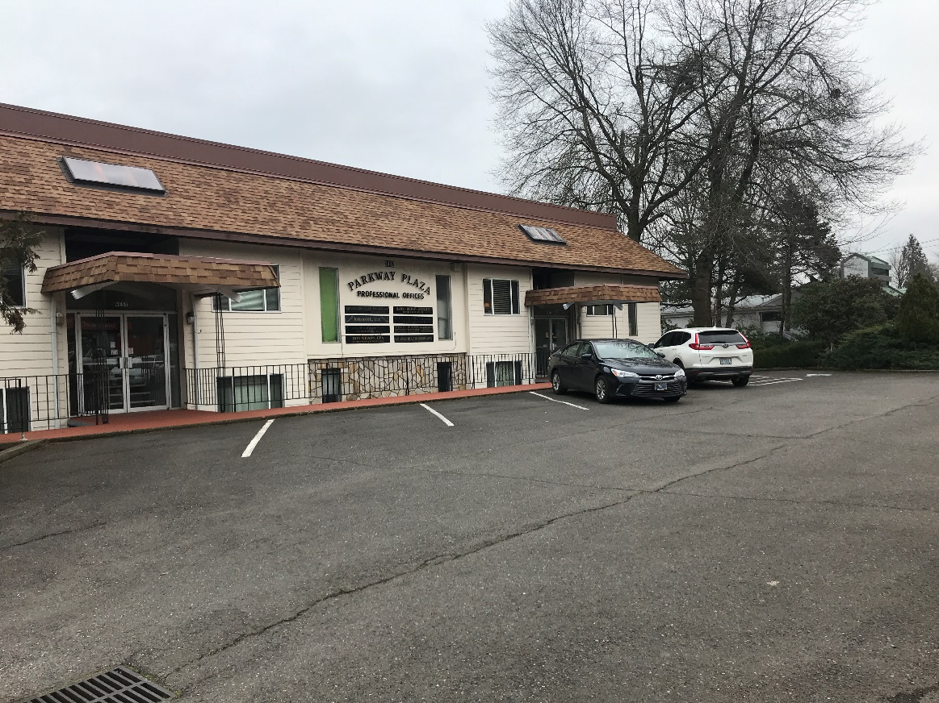

**Professional offices near I-205 Freeway**

2424 SE 101st Avenue, Suites 101/205/206, Portland, OR

* Located at signalized intersection. Parking on both Division and behind.
* Suite 101- large rec/admin area, 3 treatment rooms, lab, priv. office, w/d hookup.
* Suite 205- large rec/admin area, 4 treatment rooms, priv. office, deck, nat. light.
* Suite 206- smaller rec/admin area, 2 treatment rooms, lab, priv. off., deck.
* Large windows, private restrooms, A/C, Separate HVAC systems, sinks, every day, 24 hr. access.
* Suite 101 rent: $1,850/mo., Suite 205 rent: $1,900/mo., Suite 206 rent: $1,100/mo. Mod. Gross.

Vacancies a result of recent Chiropractic, massage therapist practitioner retirements.

Available 6-23. Call office to schedule appointment for walk thru.

* 2 larger offices, 1 smaller unit avail.

Approx. 1,150-1,300 sf #101 and #205.

#206 approx. 800

* Med/prof. uses.
* W/S and Garb. Inc.
* Great access to 1-205 at SE Division
* ng
* High exposure site

**DEVLIN PROPERTIES CONTACT: MIKE DEVLIN**

10425 SW 55TH AVENUE phone: 503-246-4045/ 503-901-5407

PORTLAND, OR 97219 [mdevprop@hotmail.com](mailto:mdevprop@hotmail.com)

Enclosed information provided by sources deemed reliable, however, not guaranteed.

**For Lease**