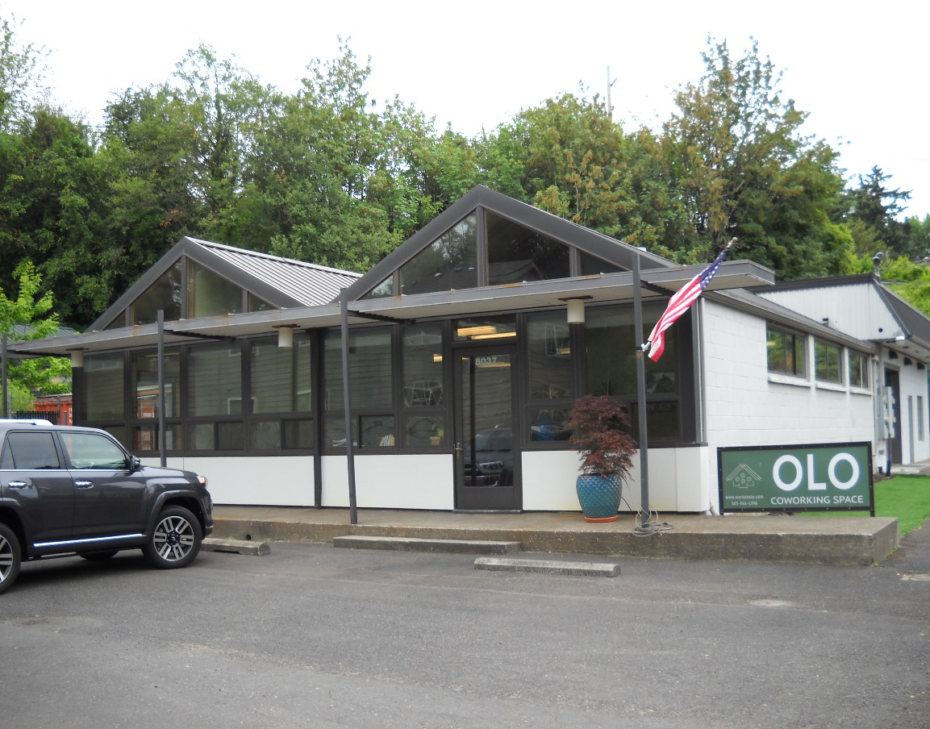

**Close-In SW Flex-Space site near I-5**

8037 SW 17th Avenue, Portland, OR 97219

* Opportunity to lease multi use free standing facility.
* Located off SW Multnomah Blvd. with access from SW Barbur Blvd. and SW 19th Ave.
* Open floor plan office space with vaulted ceilings, natural light, kitchen/conf. room.
* Two restrooms, one with shower. Gas heat/AC. Less than 5 miles to downtown.
* Rent: $3,200/month gross (includes prop. taxes and insurance). Available 5-23.
* Please call Mike Devlin to schedule walk thru appointment. Do not disturb occupant.

Rent: $3,200/mo. gross

Open floor plan.

Terrific Flex-space use.

Approx. 2,100 sf office.

Access from SW Barbur.

Excellent 1-5 access.

Possible exercise uses.

Good parking/signage.

* Retail/production
* Warehouse
* 4 Bay doors 14’ hi.
* Great signs. CG zone
* High exposure site.

**DEVLIN PROPERTIES CONTACT: MIKE DEVLIN**

10425 SW 55TH AVENUE phone: 503-246-4045/ 503-901-5407

PORTLAND, OR 97219 [mdevprop@hotmail.com](mailto:mdevprop@hotmail.com)

Enclosed information provided by sources deemed reliable, however, not guaranteed.

**For Lease**